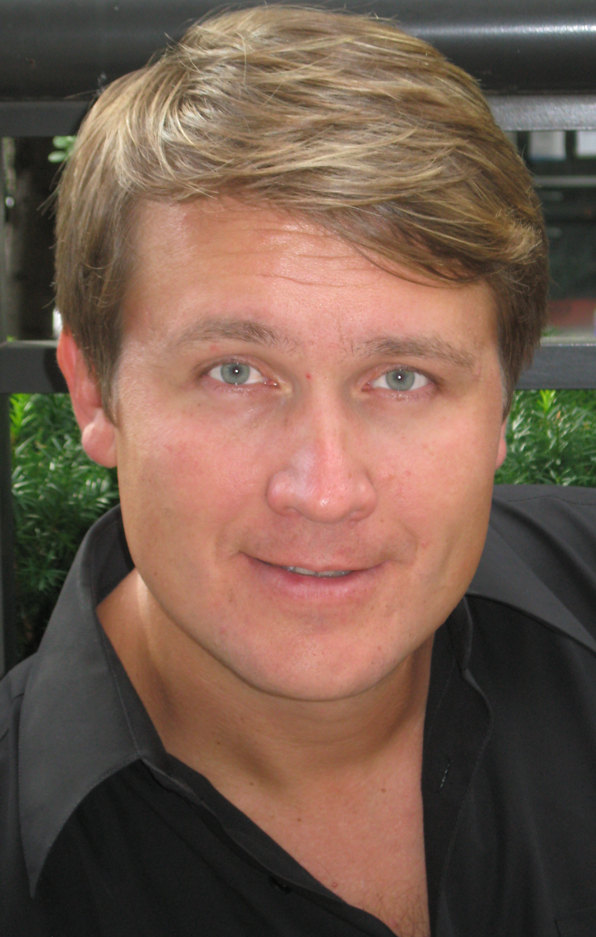

Konstantin Stepanov, tenor. Birthplace: Uzbekistan. This season at City Opera: debut as B.F. Pinkerton in Madama Butterfly. Career highlights: made his American debut in 2008 in Carnegie Hall as The Young Man in Rimsky-Korsakov’s The Tsar’s Bride with Eve Queler’s Opera Orchestra of New York; Alexander Gretchaninoff’s Liturgia Domestica with Saratoga Choral Festival; Alfredo in La Traviata and Lensky in Eugene Onegin in the Grand Hall of Moscow State Conservatory; Bastien in Bastien und Bastienne and the title role of Gretry’s Peter the Great with Helicon Opera in Moscow; toured with the Tula State Philharmonic in evenings of Russian folklore songs and also sang arias from Rienzi, Lohengrin and Die Meistersinger in Moscow’s Rachmaninov Hall. Upcoming engagements: debut with Lyric Opera of Chicago as Malcolm while covering Macduff in their Macbeth.

